# **Final Report**

# **CSCE 462 – Microcomputer Systems**

# **Spring 2021**

## **Project: Social Distancing Detector**



Members: Brandon Pham, Reyandra Okvianto

Contact information:

[brandonpham29@tamu.edu](mailto:brandonpham29@tamu.edu), (469-260-6463) [rey_okvianto36@tamu.edu](mailto:rey_okvianto36@tamu.edu), (832-444-7335)

**Summary**

The purpose of this system is to monitor the well-beings of people while COVID-19 pandemic is still present. It is a challenge for society to monitor the ways of preventing the spread of the virus, but as the world adapts common guidelines to decrease the risk, our system will aid in monitoring social distancing. The system will be a portable device that utilizes OpenCV to filter out objects and detect human presence. This portion of the system will be combined with an ultrasonic distance sensor to determine the distance between the user and the person approaching. After the detection of an oncoming human and the measured distance is under 6ft, the system will alert the user by sending a signal/pulse into our circuit that causes an alarm/buzzer to go off.

**Background & Introduction**

As society continues to combat the spread of COVID-19, it is crucial for people to learn how to navigate through their daily activities while abiding to specific guidelines issued by the Government. Accountability and trust is accounted for each and every individual to do their part (wear a mask, maintain 6-ft apart, etc.) in order to minimize the spread and contraction of the virus. However, it is a burden to have leaders of companies, clubs, and organizations constantly supervise their members/peers in all scenarios. One of the biggest challenges most people face when it comes to maintaining social distancing is determining what actually constitutes as 6-ft apart and how can one tell if they are in the proper approximation from another person without tools to measure distance on hand. Our team wanted to try and tackle this problem because of how relevant it is to our everyday lives and we see that this could offer a solution that would enhance the lives of others while following COVID-19 guidelines. We thought of developing some sort of portable device that could detect a nearby human and determine the distance between the user and that other person. Depending on the distance calculated, if the distance between the user and the nearby human is less than the required amount of distance for maintaining social distancing (less than 6-ft), the device will cause the alarm feature to release a small and short noise to notify both the user and nearby human of their close encounter. One of the biggest challenges for our system will be the ability to distinguish between what is considered a human and what is not in the eyes of our device’s camera. We plan to use resourceful libraries such as OpenCV which is a Python library which utilizes numerical analysis in order to solve computer vision problems (i.e. in our case, we will need to perform human recognition). Portability/usability is another big issue we will have to address. Considering our initial model, it would not be applicable for users to have to carry around a large and disorganized device and have them use it in their everyday activities. Through future experiments and data collected, we will be able to determine the scale and location of where the device needs to be placed to offer optimal results and flexible/comfortable usability for the user.

When brainstorming ideas for projects, one thing that our team agreed on was that we wanted to tackle a solution that required extensive hardware and software design/implementation. We looked at past year’s projects and scanned the internet for ideas in order to narrow down our decision. After a lot of research, computer vision was a fascinating topic that we wanted to explore and hope to implement within our project. In addition, we heavily considered what current issues our world faced and how it affected our daily lives. With the COVID-19 pandemic still relevant, we agreed that we wanted to develop something that incorporated computer vision into something that could limit the spread of the virus. We looked at different systems that handled motion detection and human recognition at its simplest form (open source projects that utilized OpenCV, motion detection security systems, etc.) and expanded ideas in order to accomplish our goal for the device.

**Design Process**

Materials used:

* Raspberry Pi
* Camera module (compatible with raspberry pi)
* Ultrasonic sensor
* Portable Battery
* Buzzer

The first action of the project was acquiring the sensor and the camera components. During the first week of the project the sensor delivered and the first step taken was to make sure the sensor functioned the way we wanted it to. The ultrasonic sensor of choice was the HC-SR04. This specific model was chosen because of its price point at under $5 per unit. The sensor is most effective within the range of 5 meters. The HC-SR04 would work hand in hand with the Raspberry Pi through the GPIO pins as seen in the configuration below.

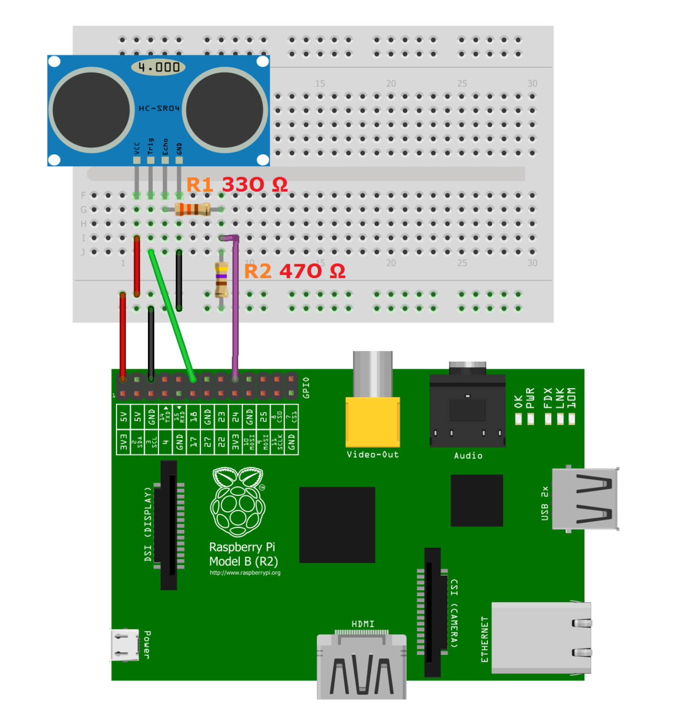

The basic functionality of the sensor is that it uses ultrasound and its reflection, along with the time it takes to travel, to measure the distance from the object to the sensor. The code implementation of this logic can be seen in our distance() function below.

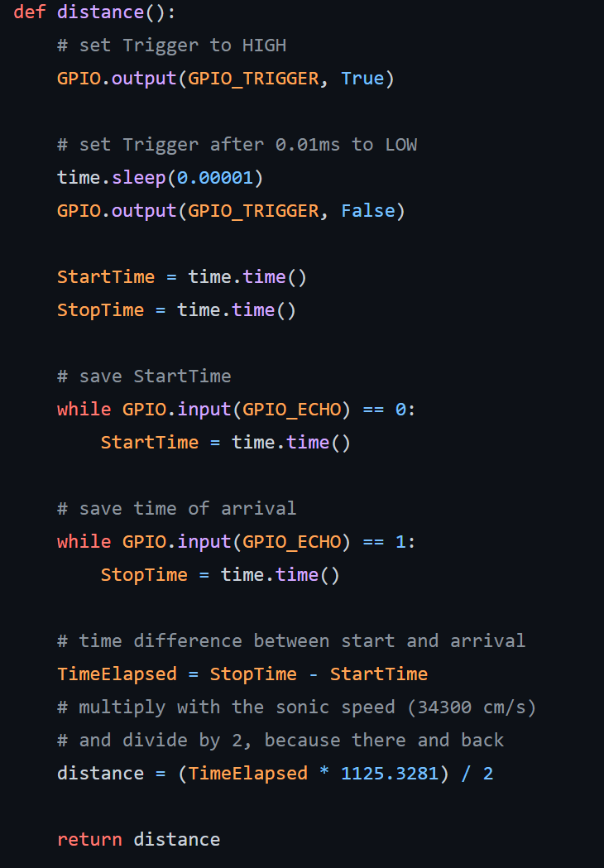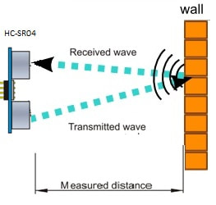

The original program measured the distance in cm, so our code was slightly altered to convert the distance to read in feet for our purposes. After testing the basic functionality of the sensor, more in depth testing was performed in order to get the best data points possible. The two biggest takeaways from our initial testing was how the angle of the sensor and shape of the object being detected was affecting our readings. When working with the HC-SR04 the readings of flat objects were very consistent while trying to detect the distance from a human would result in worse data points. Along with that, the sensor has to be completely perpendicular to the object it is detecting because it has to receive the reflected ultrasound correctly. After these findings, we continued to test the sensor at the lower chest/belly area to detect a human as that was the flattest part of the body that would receive consistent readings. Regardless of its cheap cost, the functionality of the sensor served its purpose of detecting its distance from an object.

The next essential component was the camera module to detect humans. The raspberry pi camera module is unique to other computer webcams, so when it first came in we had to figure out how to config the raspberry pi to detect the camera along with how to install the camera properly. The raspberry pi could easily be configured to detect the camera through either the system preferences settings or the raspi-config command on the terminal. As for installing the camera onto the raspberry pi, the camera slit at the end was slid into the module slot behind the ethernet port as seen in the picture below.

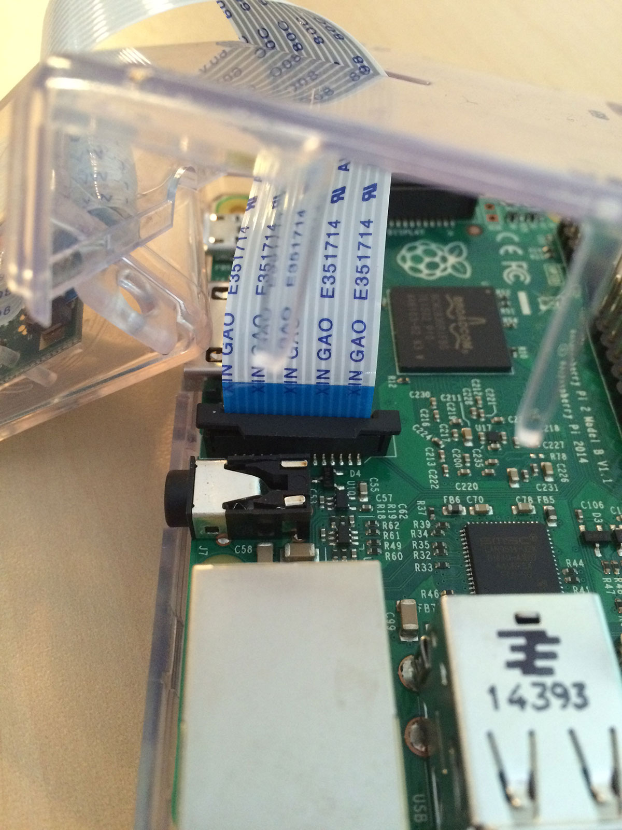

Once the camera was installed we made sure that the raspberry pi actually detected it and was able to capture an image. The code below is how we tested the camera’s basic functionality.

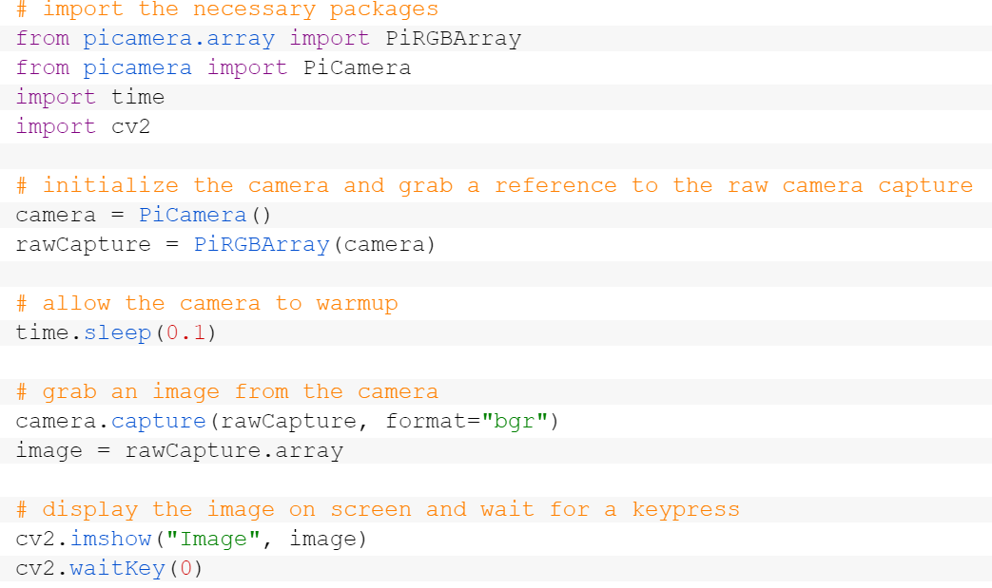

From there we had to install OpenCV which is a python computer vision library that will use the camera to recognize a human. This step was the most difficult in the installation process of the camera as the OpenCV is very large to install and many dependencies where one wrong step can mess up the entire process. The installation ended up taking over 5 hours to complete on our raspberry pi. After the installation was completed we then had to create a program that would recognize a human. For human detection we decided to go with facial recognition as that was the most effective model we tested in the OpenCV cascade classifiers. The cascade classifiers also have upper body and lower body detection, but all humans are different so it was harder to get consistent recognition compared to the facial detection. OpenCV does a lot of the work here for us as it already has a trainer for the facial recognition classifier. Optionally we can continue to train the classifier with our own faces if we would like, but we didn’t have any major issues with its current state. A few main concerns with the OpenCV facial recognition was the lighting and eye glasses. If the lighting is not bright enough then the camera may not pick up the face as easily. Additionally, if the person is wearing glasses it may mess with the scan, this is where additional training to the classifier may be useful with the glasses. Lastly, the camera module frames per second is very low so there may be a delay with facial recognition if the target is moving too fast. This could be solved with another external USB camera but that would make the system bulkier. The code on the right is what was used for facial recognition utilizing OpenCV.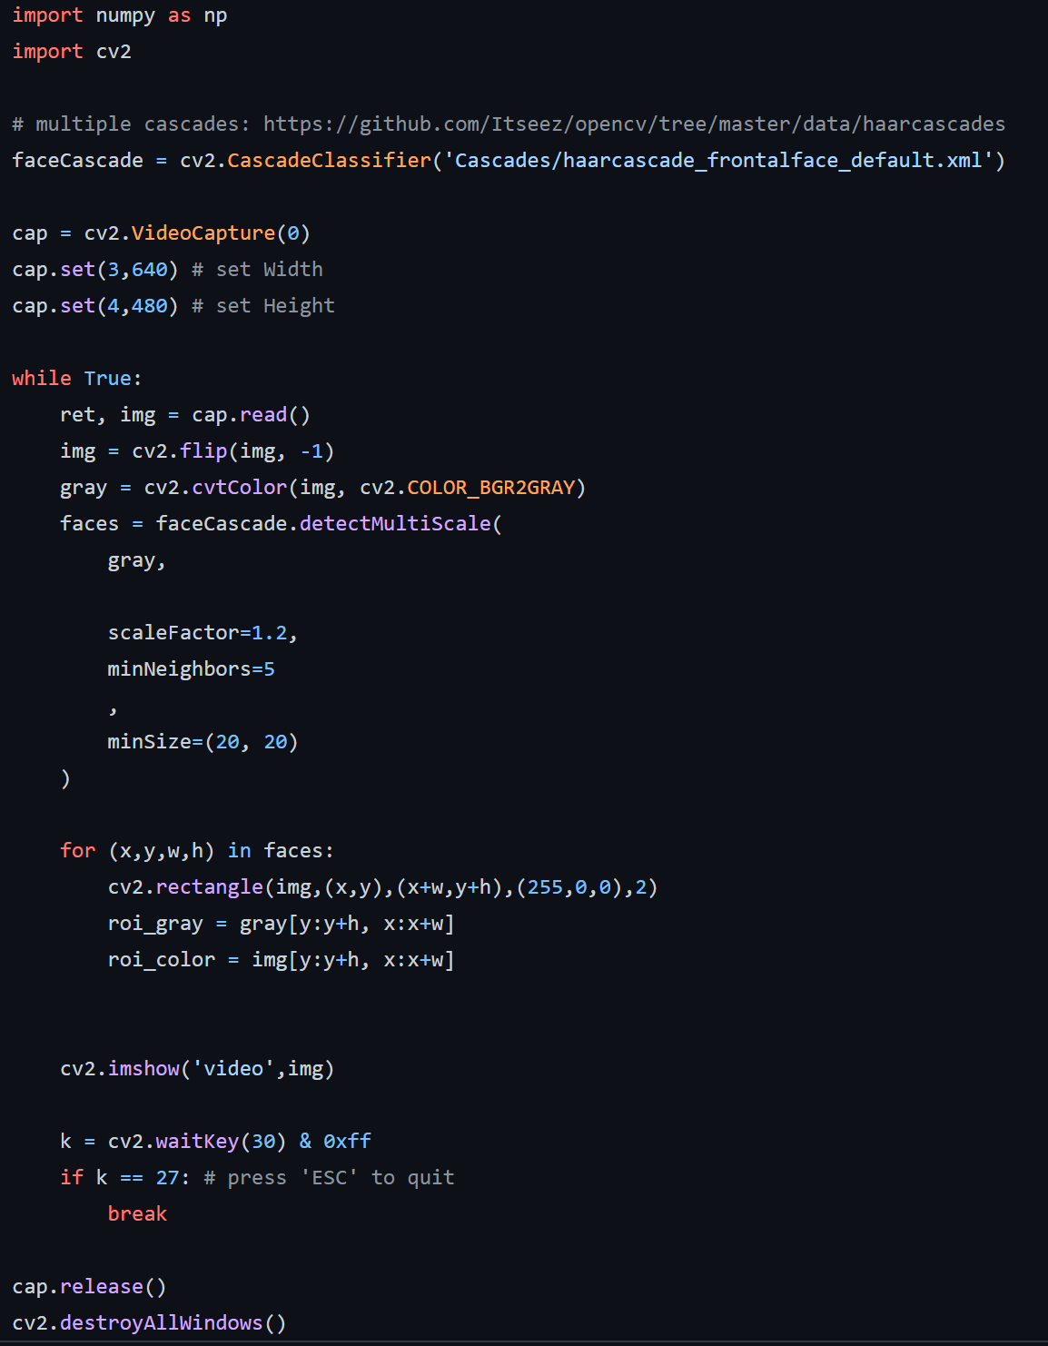

After we were able to get the functionality on both of the key components, we combined the two to create our final system. The idea is that, whenever the camera detects a face, that means there is a human detected. Once that happens the sensor is triggered and sends the ultrasounds to detect the distance to that human. If that distance is within 6 feet then the buzzer will be activated alarming the user and the approaching person. The buzzer was simply installed by connecting its pin to a GPIO pin and setting that to high whenever the certain criteria was met. The code below demonstrates the logic of our system after combining the two components.

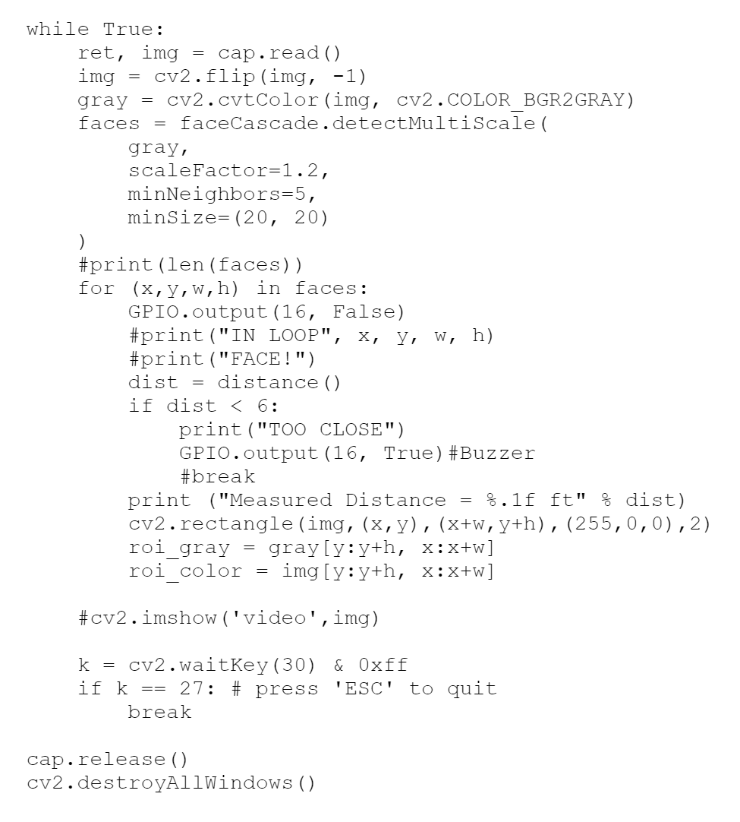

The last step done was encapsulating the entire system in a smaller case to allow portability. Before moving everything over to the wooden case, the wires and resistors were moved over to a PCB board. The main components to accomplish our final encapsulation was a 5V portable battery, and a balsa wooden case. The 5V battery had the exact specifications needed to power the raspberry pi through micro usb input which allowed the system to work without it being plugged into the wall. Normally, when we would test our product we would have it plugged into a monitor, however, when using the battery we had to SSH to it through another device. With SSH and a 5V battery the system was now functioning, the final component was to minimize the size and encapsulate the entire system in a small container so the user can carry it around. In the end we decided to use balsa wood as it was a cost effective material. The design was a simple box container where we could lay the components inside with slits all around to allow airflow and wire management. The battery was attached to the bottom of the wooden case. Below is a picture of our final design.

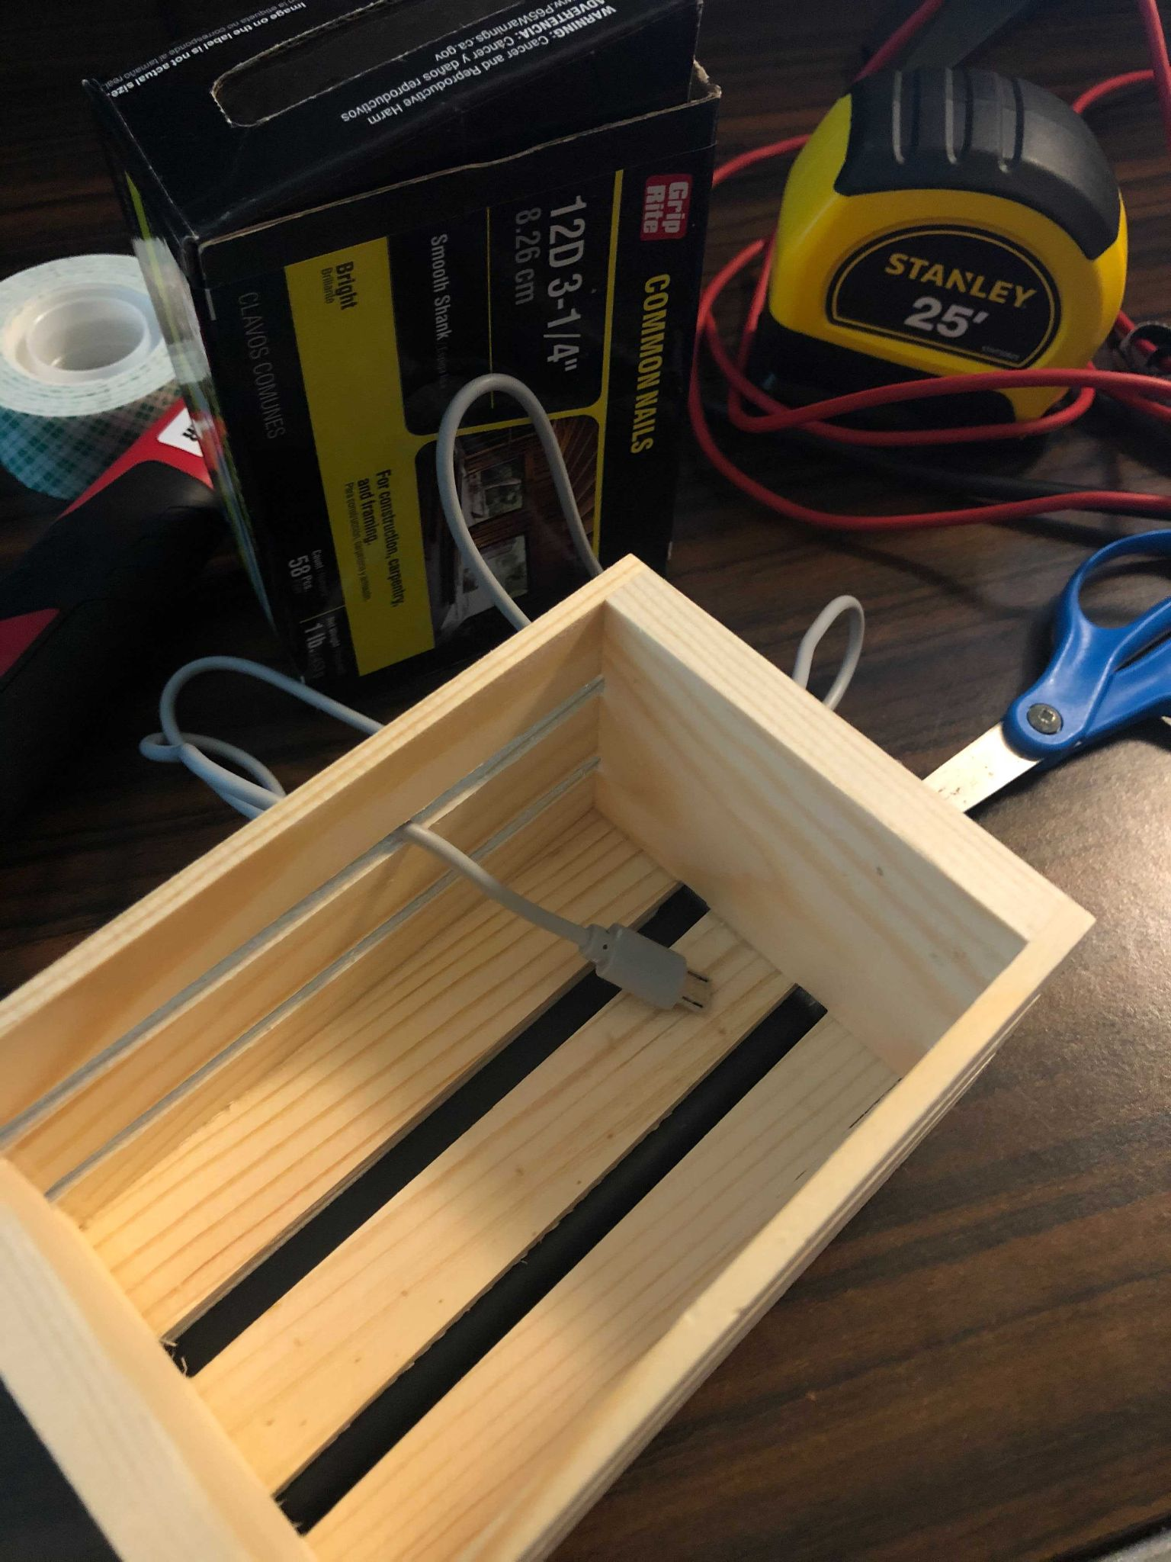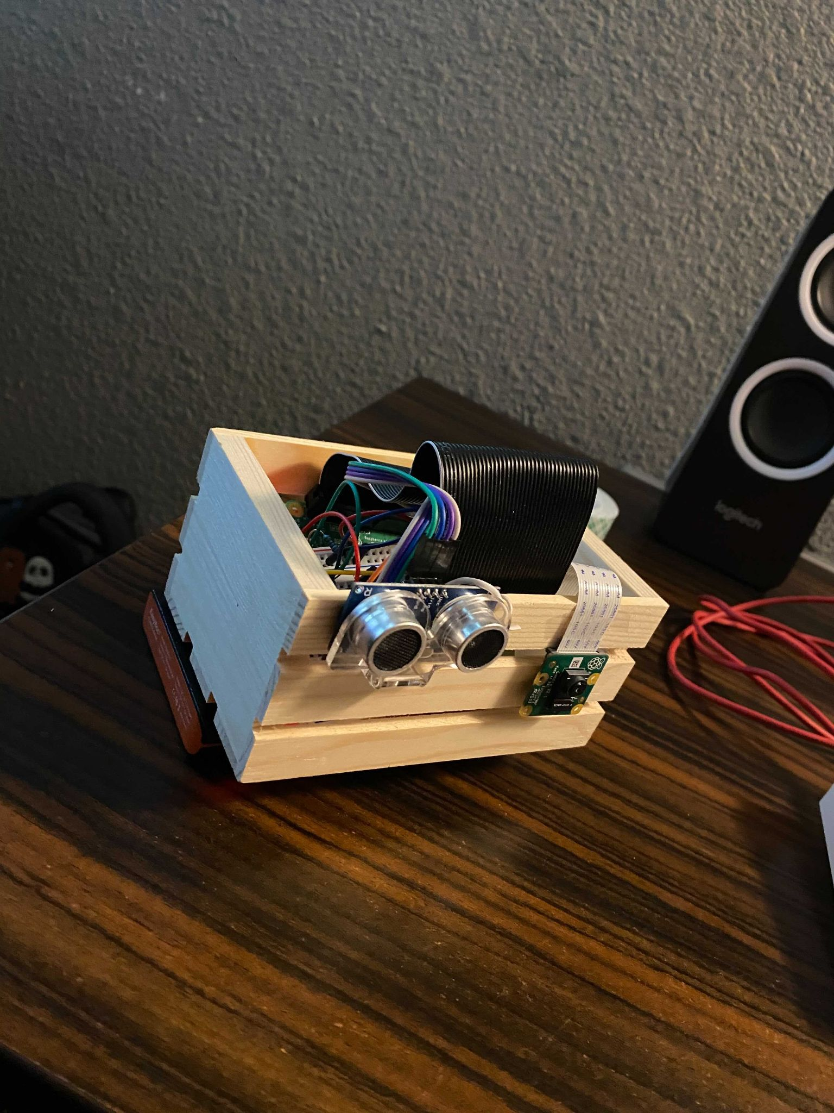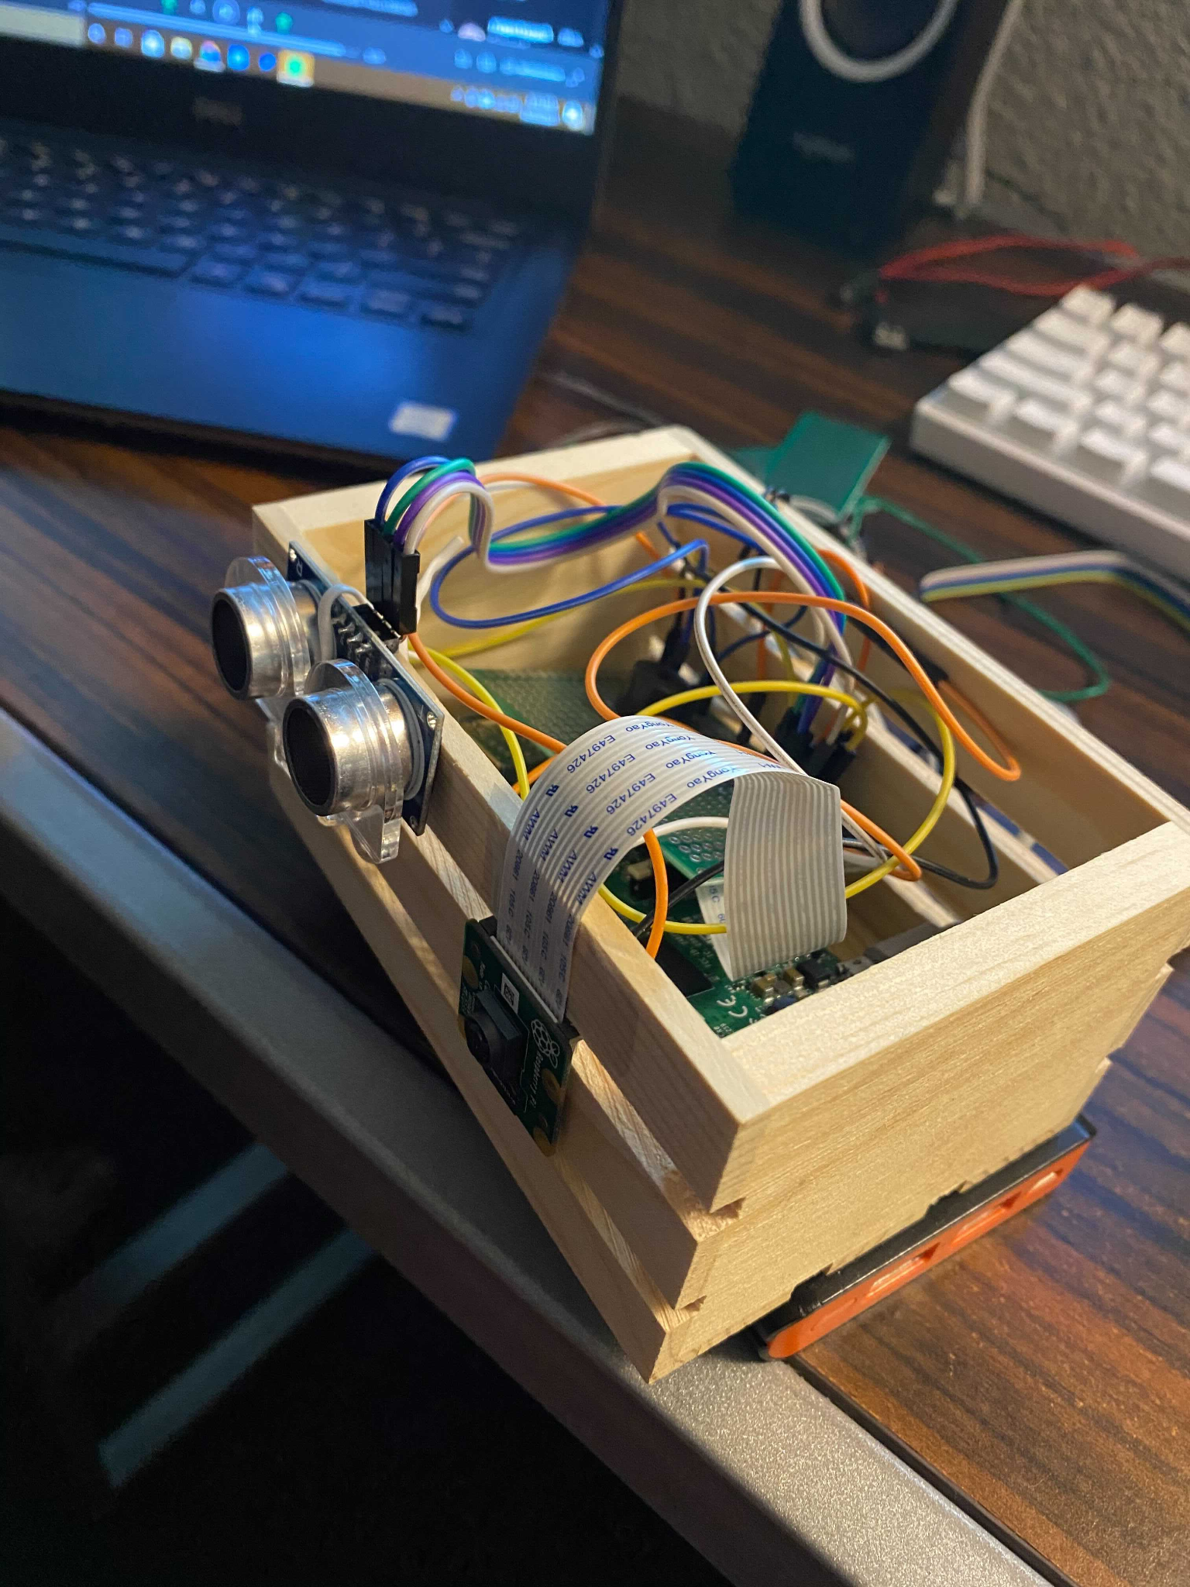

Once everything was included in the balsa wood casing we performed our final tests to ensure everything was working as intended.

**Final Project Demonstration**

<https://drive.google.com/file/d/1g9nwh3HSRuq4vOx4PQTBpMoWTgoIH_5N/view?usp=sharing>

**Challenges Faced**

1. Accurately Measuring Distance
   1. Our Solution:
      1. Ultrasonic Sensor (HC-SR04)
      2. High Sampling Rate & Filtering Noise
      3. Measuring against somewhat flat surfaces
   2. Alternative Solution:
      1. Better Sensor - MaxBotix 1000 series models (more expensive and larger sized sensor with higher accuracy)
      2. Measuring against “perfectly flat” surfaces
2. Detect Human Presence
   1. Our Solution:
      1. Raspberry Pi Camera Module
      2. Facial Recognition through OpenCV Library
   2. Alternative Solution:
      1. PIR Sensor - measure heat (humans have high body temperature)
      2. Motion Sensor (downside - less room for error detection)
3. Portability/Usability
   1. Our Solution:
      1. Scaling down entire system multiple times
      2. Hand-held case
   2. Alternative Solution:
      1. Wearable mounted case
      2. Use a smaller microprocessor that can work just as effectively as the Raspberry Pi model

**Bill Of Materials**

|  |  |  |
| --- | --- | --- |
| **Item** | **Price** | **Link to Shop** |
| Raspberry Pi 4 | Purchased | NA |
| Camera Module | $24.96 | [Amazon](https://www.amazon.com/gp/product/B01ER2SKFS/ref=ppx_yo_dt_b_asin_title_o00_s01?ie=UTF8&psc=1) |
| Ultrasonic sensor | $8.99 | [Amazon](https://www.amazon.com/XiaoR-Geek-Ultrasonic-Distance-Raspberry/dp/B07B94C7KT/ref=sr_1_9?dchild=1&keywords=HC-SR04&qid=1616019282&sr=8-9) |
| Wires | Purchased | NA |
| Battery Pack | $23.95 | [Amazon](https://www.amazon.com/Battery-Pack-Raspberry-4000mAh-Suction/dp/B08RXLHT5R/?tag=makeusw-20&linkCode=ogi&th=1) |

Total Cost: $57.90

**Work Schedule**

|  |  |
| --- | --- |
| **Week** | **Plan** |
| Week 1 (March 29th -April 4th) | Connect hardware parts and test basic functionality of the sensor. |
| Week 2 (April 5th - April 11th) | Connect the camera and test the basic functionality of the camera. |
| Week 3 (April 12th - April18th) | Continue Testing Sensor for better readings and begin working on installing OpenCV. |
| Week 4 (April 19th - April 25th) | Work on sending an output signal when distance is within 6 feet of the sensor. Finish up installing OpenCV library. Start combining camera and sensor integration. |
| Week 5 (April 26th - May 2) | Continue combining both aspects of the project, with detecting a human and triggering sensor to detect distance. Begin final testing and start the report and demo. |

**Teammate Agreement**

*Both teammates agree to at least meet in person once a week to work on the project, along with other meetings virtually through zoom or discord. The project will not be worked on individually by either teammate; that way the work will be equally divided among both members. The price of the materials will also be split halfway between both parties. Either party will speak openly and honestly about their opinions towards the project details.*

Brandon Pham

x Brandon Pham

Reyandra Okvianto

x Reyandra Okvianto

References

<https://tutorials-raspberrypi.com/raspberry-pi-ultrasonic-sensor-hc-sr04/>

<https://www.instructables.com/Real-time-Face-Recognition-an-End-to-end-Project/>

**Slack Workspace Log**



